Custom Crayons!

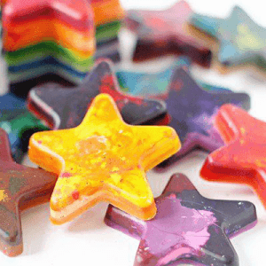
This is a super fun and easy way to make crayons with your favorite colors swirled into one!
This activity needs to use the oven or microwave, so make sure to have an adult be your craft-buddy to take care of any steps that use the oven or microwave!

Materials:

- Crayons
- Microwave oven or regular oven
- Heat-safe silicone molds (any shape you like!) and a flat baking sheet (no baking sheet if microwave method)
OR
- Metal cupcake tin (oven method only)
- Optional: toothpicks
Note: if you are using the oven method and choose to use a metal cupcake tin, make sure to grease the pan or use muffin cups to make the crayons easier to remove!

Instructions for Oven method:

- Preheat the oven to about 200˚F
- Peel any paper off of the crayons
- Break the crayons into small pieces using your hands or scissors if you have help!
- Place crayon pieces into the molds. Pick colors that you think might look nice together! Don’t put too many colors though, or the crayons may turn brown.
- If using a silicone mold, place it on the flat baking sheet.
- Place your crayon-filled molds into the oven for 10-20 minutes
- Check your crayons often, and have your adult craft-buddy remove the molds from the oven once the crayons are all melted.
- OPTIONAL: use a toothpick to swirl some the melted crayon wax around to mix colors if needed.
- Let crayons cool until baking tin/sheet is cool and the crayons are hardened.
- Remove crayons from the molds and make beautiful rainbow art!

Instructions for microwave method:
- Peel any paper off of the crayons
- Break the crayons into small pieces using your hands or scissors if you have help!
- Place crayon pieces into the molds. Pick colors that you think might look nice together! Don’t put too many colors though, or the crayons may turn brown.
- Place your crayon-filled molds into the microwave, and microwave on high for 2-4 minutes.
- Check your crayons and have your adult craft-buddy remove the molds from the microwave once the crayons are mostly melted. If not melted, microwave 2 additional minutes and check again. Continue this until the crayons are mostly melted!
- OPTIONAL: use a toothpick to swirl some the melted crayon wax around to mix colors if needed.
- Let crayons cool until the mold is cool and the crayons are hardened.
- Remove crayons from the molds and make beautiful rainbow art!

