Stress Balls
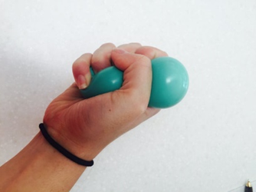
Supplies:
- 2 balloons
- Cornstarch
- Water
- Small Bowl
- Empty Water Bottle
- Scissors
- Utensil to stir

Directions:
- In your bowl, place 6 tablespoons of corn starch and slowly work in 3 tablespoons of water.
- Slowly stir mixture until smooth, working out all lumps.

- Slightly bend edge of bowl to create a small spout to pour mixture into empty water bottle.

- Blow up both balloons to stretch them out and then place one balloon over the top of the water bottle.

- Turn water bottle upside down until all of the mixture has gone into balloon (you may need to squeeze the bottle to force all of the mixture in).

- Take the balloon off of the bottle and tie a tight knot after making sure that no air is trapped

- Cut off the end of the knot after making sure the knot is secure.

- Cut off the neck of the second balloon.

- Place filled balloon, knot inward, inside the second balloon.

- Squeeze and de-stress!!!

STEP 1  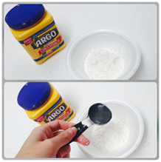 | STEP 6  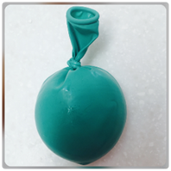
STEP 2  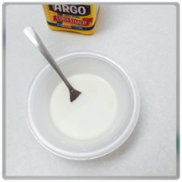 | STEP 7  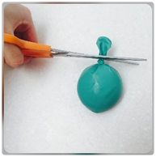
STEP 3  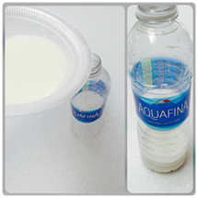 | STEP 8  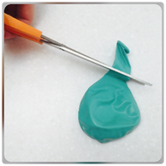
STEP 4  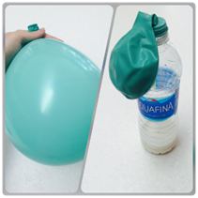 | STEP 9  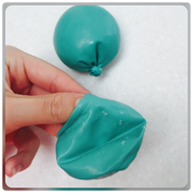
STEP 5  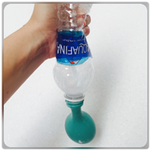 | STEP 10  